|  |  |
| --- | --- |
|  | Student Name _______________________    **Eastern Goldfields College**  Mathematics 2019  Test 6 (U2 T3) 8% – Calculator Free1 |
|  | **Total Marks: 17 marks** |

**Time allowed: 15 minutes**

**No calculator or notes permitted for this section.**

**Question 1** [3 Marks]

Complete the table by choosing the best **Data Display** and **Data Type** from the options provided.

You can choose each option more than once.

**Data Type**

* Numerical
* Categorical

**Data Display**

* Column graph
* Dot Plot
* Back to back stem and leaf diagram
* Histogram
* Box & whisker Plot

|  |  |  |
| --- | --- | --- |
|  | **Data Display** | **Data Type** |
| The heights (measured to the nearest cm) of 20 boys and 20 girls to compare them. |  |  |
| The eye colour of all Year 11 students. |  |  |
| The foot length of the members of your class |  |  |
| House prices in various suburbs |  |  |
| The birth month of all Essentials students. |  |  |

**Question 2** [4 marks – 1, 1, 1, 1]

Three groups of 10 students do a spelling test marked out of 10. The scores achieved by each group are shown in the dot frequency graphs below.

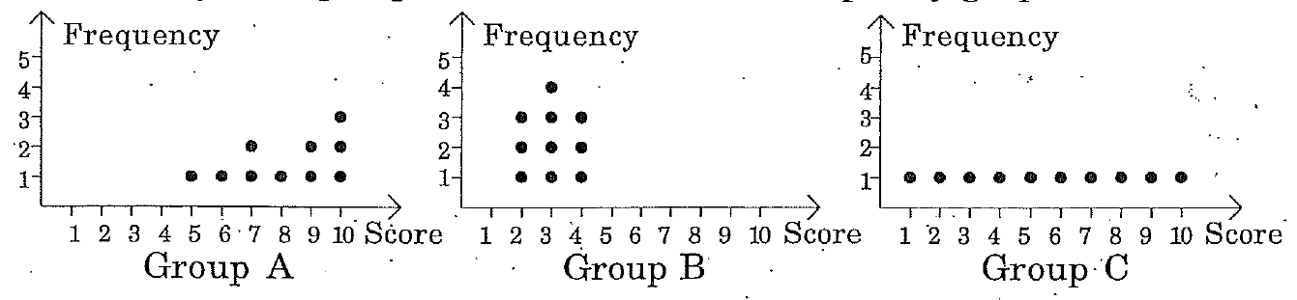

State which of the three groups have scores with

1. the greatest standard deviation ii) the smallest standard deviation
2. the greatest mean iv) the smallest mean

**Question 3** [2 mark]

Seven children attend an afterschool play centre. Their ages are listed below.

4, 5, 7, 8, 9, 9 and 11

If two new children, aged 6 years and 9 years, join the centre, which of the following statements is true?

A The mode will change

B The mean will change

C The median will change

D The range will change

E None of the above

F All of the above

**Question 4** [ 5 marks]

The number of break-and-enter offences in a rural city were recorded over a number of months.

21, 25, 17, 23, 16, 21, 41, 22, 25, 20, 22, 11, 20, 12, 13, 12, 6, 12, 10, 19,

30, 22, 21, 14, 34, 33, 34

Draw a boxplot for this data on the grid below.



**Question 5** [3 marks – 1, 2]

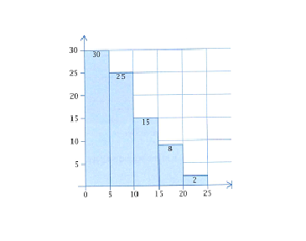

1. Describe the distribution shown.
2. Give an example of what data could be represented in this graph and justify your answer.

End of Calculator Free Section

|  |  |
| --- | --- |
|  | Student Name _______________________  **Eastern Goldfields College**  Mathematics Essentials 2019  Test 6 (U2 T3) 8% – Calculator Assumed1 |
|  | **Total Marks: 39 marks** |

**Time allowed: 40 minutes**

**Calculator and notes are permitted for this section.**

***Show all working where appropriate to obtain full marks.***

**Question 6** [7 marks: 1, 1, 1, 1, 2, 1 ]

This dot plot shows the number of births in the Goldfields region of Western Australia recorded each month for one year.

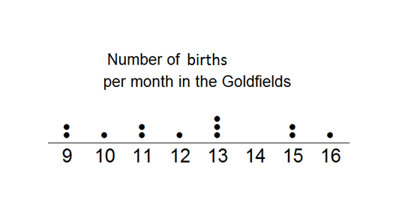

a) What type of data is represented in this graph?

b) Calculate the range of the scores.

c) Determine the mode. __________________

d) Determine the median. __________________

e) Calculate the mean.

f) Complete this sentence:   
For the Goldfields region, you would expect approximately __________ births per month.

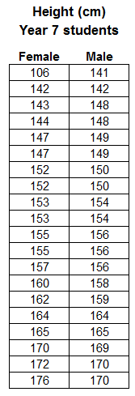**Question 7** [15 marks: 2, 2, 3, 4, 2, 2]

Consider the data to the right, showing the heights of 20 male and 20 female Year 7 students, taken from CensusAtSchool.

1. Identify any outliers in the data.
   1. For any you find, explain why you consider it an outlier.
2. Explain the effect the outlier(s) have on the:
   1. Mean
   2. Median

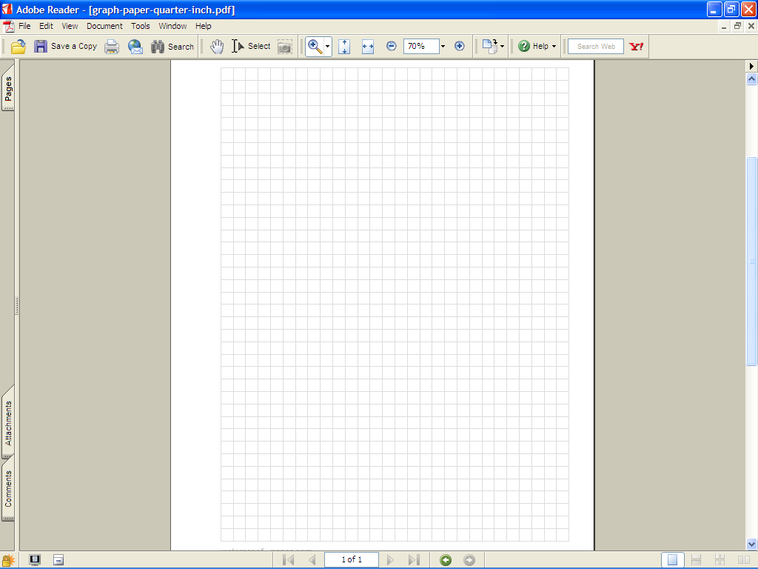

1. Make a back-to-back stem and leaf diagram to display this data.
2. Complete the table below, showing your working, to summarize the statistics for this data.

|  |  |  |
| --- | --- | --- |
| **Statistic** | **Female** | **Male** |
| Mode |  |  |
| Median |  |  |
| Range |  |  |
| Mean |  |  |

1. Using your stem and leaf plot and/or the table in d), compare the data for males and females.
2. Which average is best and and justify your choice.

### Question 8 [12 marks: 1, 5, 2, 4]

a) Eric is in Class A, he scored 5 on the test. **Label** **the two box plots** with their class names.

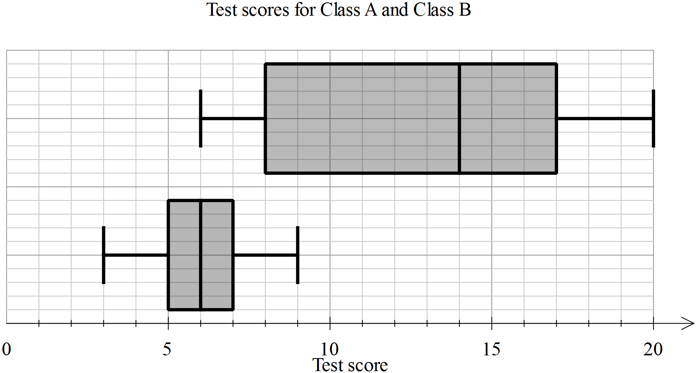

b) Use the table below to enter the appropriate values for each of the plots.

|  |  |  |
| --- | --- | --- |
| **Statistic** | **Class A** | **Class B** |
| Minimum |  |  |
| First quartile |  |  |
| Median |  |  |
| Third quartile |  |  |
| Maximum |  |  |

c) Calculate the range and interquartile range for each class, showing the working, in the table below.

|  |  |  |
| --- | --- | --- |
| **Statistic** | **Class A** | **Class B** |
| Range |  |  |
| Interquartile range |  |  |

1. In each of the statements below, write A and B as appropriate to make the statement true.

* Class ______ has a much greater range than Class ______
* The minimum for Class ______ is the same as the median for Class ______
* For Class ______, the data is symmetrical and for Class ______, 100% of the scores are 6 or greater.
* The standard deviation of Class _____ is much lower than the standard deviation of Class ______.

### Question 9 [5 marks]

The frequency table for the heights of a group of soccer players is given below.

Graph this information below.

|  |  |
| --- | --- |
| Height | Frequency |
| 175 up to 180 | 3 |
| 180 up to 185 | 1 |
| 185 up to 190 | 12 |
| 190 up to 195 | 7 |
| 195 up to 200 | 4 |
| 200 up to 205 | 3 |



End of Test